Product Description

# Product Summary

* **Title**: AstroloZ
* **Purpose**:

Currently, there are many applications for viewing horoscopes and astrology, but all without providing Vietnamese language. So it's difficult for Vietnamese people to use. AstroloZ is created to provide free horoscopes daily and astrology services to users. Moreover, our application also updates interesting news daily about astrology or even helps customers explain their birth chart themself and so on. Finally, AstroloZ will suggest suitable products for customers based on the collected data through the sales system integrated into it.

# Project Team

|  |  |  |
| --- | --- | --- |
| **Name / Role** | **Student ID** | **Email** |
| **Cao Hoàng Quy (Team Leader)** | SE140885 | quychse140885@fpt.edu.vn |
| **Nguyễn Thanh Hoàng** | SE140817 | hoangntse140817@fpt.edu.vn |
| **Cao Hoàng Phát Lộc** | SE140456 | locchpse140456@fpt.edu.vn |
| **Nguyễn Văn Hiếu** | SE140735 | hieunvse140735@fpt.edu.vn |
| **Phạm Thanh Tùng** | SE140843 | tungptse140843@fpt.edu.vn |
| **Huỳnh Anh Vũ** | SE141124 | vuhase141124@fpt.edu.vn |

# Key Stakeholders

|  |  |
| --- | --- |
| **Stakeholders** | **Impact to the product** |
| Admin | Manage users, manage the sales system, manage information of the astrology and zodiacs, planets, houses, user reports. |
| Guest | Search horoscopes daily, zodiacs, planets, and houses, blogs, products. |
| Registered User | View their birth chart, horoscope daily, search information about zodiacs, planets, houses, products.  Buy products.  Create and share information cards.  Follow and book an astrologer. |
| Momo/Paypal | Payment for user orders. |
| Astrologer | View their followers, accept customer booking, update calendar, and write news about astrology. |
| Facebook /Google | Register an account and login. |
|  |  |
|  |  |

# (later) Requirements

## Functional Requirements

| **Requirement ID** | **Description** | **Related Stakeholders** |
| --- | --- | --- |
| **FR_01** | View Birth Chart | Registered User |
| **FR_02** | Create information Card | Registered User |
| **FR_03** | Share information Card | Registered User |
| **FR_04** | Book a meeting with Astrologer | Registered User |
| **FR_05** | Write blog about astrology | Astrologer |
| **FR_06** | Follow astrologer | Registered User |
| **FR_07** | View Zodiac information | Registered User, Guest |
| **FR_08** | View Planet information | Registered User, Guest |
| **FK_09** | View House information | Registered User, Guest |
| **FK_10** | Add money to the account | Registered User |
| **FK_11** | View blog | Registered User, Guest |
| **FK_12** | Update blog | Admin, Astrologer |
| **FK_13** | Accept customer booking | Astrologer |
| **FK_14** | Chat | Registered User, Astrologer |
| **FK_15** | Login | Registered User, Astrologer |
| **FK_16** | Register an account | Guest |
| **FK_17** | View list product | Registered User, Guest |
| **FK_18** | Make order | Registered User |
| **FK_19** | Write review product | Registered User |
| **FK_20** | Cancel order | Registered User |
| **FK_21** | View order detail | Registered User |
| **FK_22** | View order history | Registered User |
| **FK_23** | View list user booking | Astrologer |
| **FK_24** | Accept booking from Registered User | Astrologer |
| **FK_25** | Give feedback to astrologer | Registered User |
| **FK_26** | View shopping cart | Registered User |
| **FK_27** | Update shopping cart | Registered User |
| **FK_28** | View profile | Registered User |
| **FK_29** | Edit profile | Registered User |
| **FK_30** | Update work schedule | Astrologer |
| **FK_31** | Write review blog | Registered User |
| **FK_32** | View list follower | Astrologer |
|  |  |  |
|  |  |  |
|  |  |  |
|  |  |  |

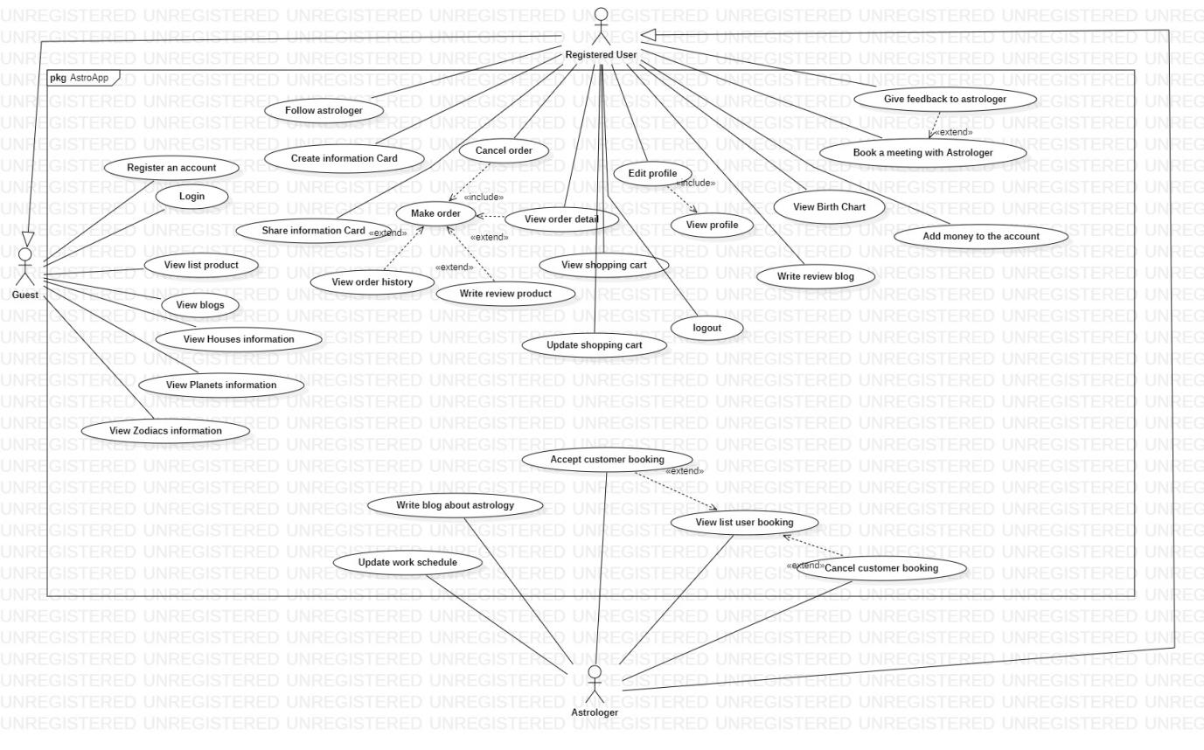

## Non-Functional Requirements

|  |  |  |
| --- | --- | --- |
| **Requirement ID** | **Description** | **Metrics** |
| **NFR_01** | Performance | - Chat does not delay more than 2s.  - Time to search for information on the application must be less than 5s. |
| **NFR_02** | Security of application | - Protect user private information for example: password, phone number, email,…  - We use encryption to keep your data private while in transit.  - We offer a range of security features, Security Check-Up and 2 step verification to help you protect your account.  - When a user forgets his password, the link used to create a new password must first be sent to the registered email address. |
| **NFR_03** | Availability | - Time can use the system.  - Ex: The system must ensure 24/7 operation, downtime per year not more than 1 hour, maintance 1 time within 2 months.  - Dependent factors to operate the system.  -Ex: If a system is installing an “Add-on” or an application built by a third-party. The system must ensure 24/7. |
| **NFR_04** | Usability | - Efficiency: minimizing manipulation of users on the screen so that they complete a task on the system as quickly as possible.  - Check the data type on each field, and immediately warn if there is an error, do not force the user to enter again and again. |